Introducing the World’s first wearable AC

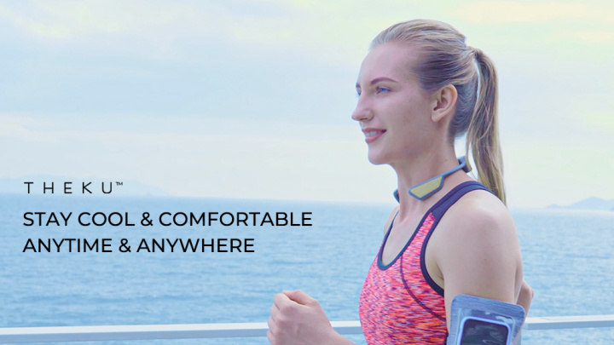

This revolutionary device is the smallest and lightest thermoelectric personal cooling wearable ever created. When worn on the neck, it provides instant cooling of the body for productivity, performance and comfort.

Whether you believe global warming or not, everyone has suffered from overheating while enjoying summer time activities, playing sports or simply just working in an uncomfortable hot office. The solution? THEKU neck cooler is a lightweight, neckband that uses low-wattage TEC (TYhermoelectric Cooling) to effectively reduce body temperatures. By providing cooling relief at the neck, TEC works to cook down the entire body.

That Muggy, Stuffy, Sweaty feeling really sucks!

Hand-held mini-fan “coolers” are so yesterday. They really only blows hot air at you. Also, the tiny and whiny noise of the fan irritates more than cools.
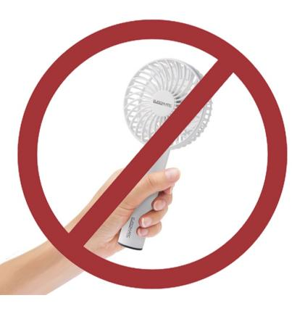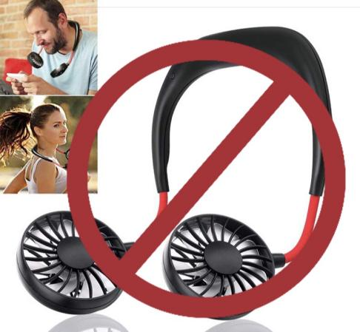

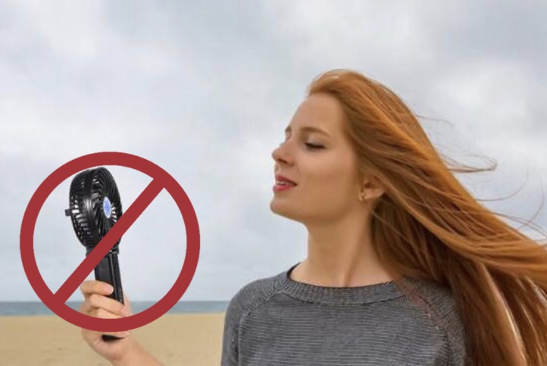

Wouldn’t it be great if you had your own personal air-conditioner that you could carry with you anywhere? How enjoyable would it be to remain cool, calm, and comfortable at your preferred temperature anytime & anywhere?

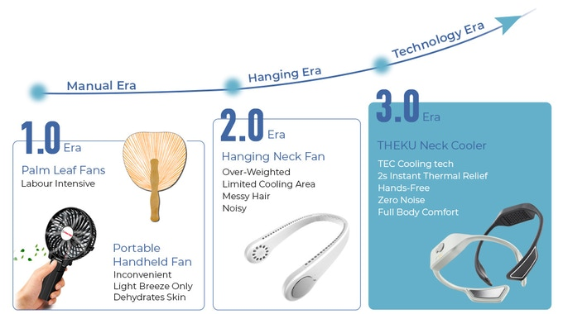

THEKU takes personal cooling to a whole new level of technology. Its innovative proprietary low-wattage TEC (Thermoelectric) cooling technique effectively maintains the perfect body temperature for you. By providing cooling at the neck, THEKU helps to cool down the entire body. Beat the summer heat by lowering temperature 5-13℃ (41°-55°F) to feel better, perform better, and get more work done.

CONTACT: tysyslimted@gmail.com

No more sweat stains or unpleasant odors. THEKU changes your comfort level, not just your body temperature. Eliminate mugginess and hot flashes in seconds with THEKU’s Thermal Relief tech and control your body’s temperature and all-day freshness wherever you are.

Hands-free and noiseless, THEKU works in all conditions to bring you coolness for better performance during any workout and helps keep you productive during office work, daily commute, working around the house, or while driving.

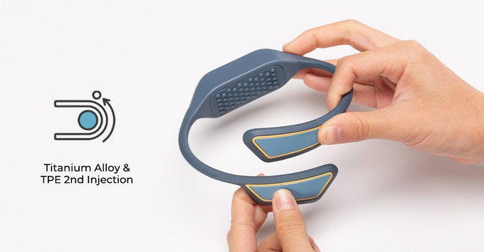

Made of a titanium memory alloy, THEKU weighs only 80g and is shaped ergonomically to comfortably fit and adapt to all body sizes.

THEKU works by placing a cooling pad on the neck and cools down the blood in the large vessels of the neck. This cooler blood travels throughout the circulation system to help cool the entire body. Control by a smart and unique algorithm, THEKU reduces the temperature of the cooling pad by up to 50⁰ F relative to the outside air and through conduction, this cooling effect is transferred to the body. It provides soothing and comfort no matter what the weather conditions are.

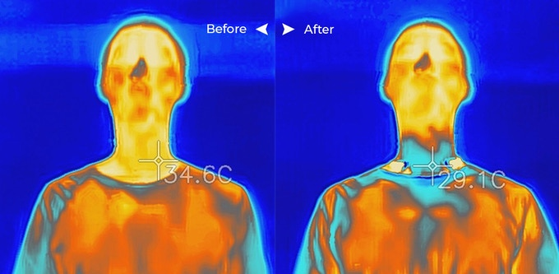

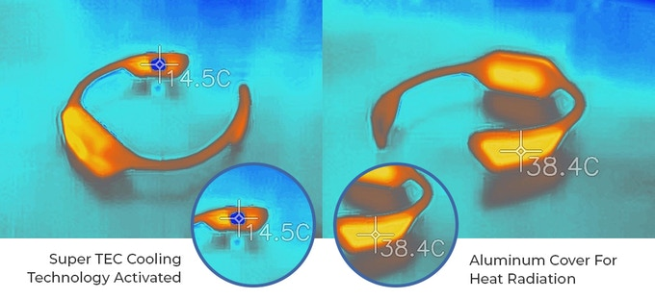

THEKU is your gateway to calmness. By balancing your temperature, the neck cooler gives you a better mood, a sharper mind, and a peaceful heart. It helps you concentrate and improves overall wellness.

Once your temperature cools to your preference, you will instantly feel much better, physically, and mentally.

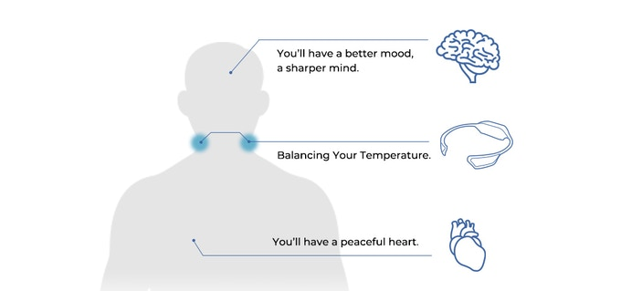

It’s never too early to get prepared. The hot 2021 summer will be here before you know it. This year, get out there and enjoy your life with a cool neck cooler. Its uni-body waterproof design is light, comfortable and IPX7 certified for water and sweat resistance. The neck cooler is your best companion for outdoor sports like jogging, golfing, basketball, fishing, climbing, cycling, motorcycling, and hiking.

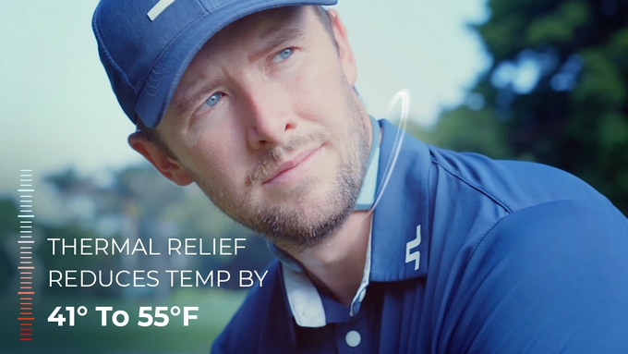

Neck-Cooler – World’s smallest and lightest Thermoelectric personal cooling device. A go-anywhere personal AC that you wear comfortably on your neck to provide instant cooling to achieve your perfect body temperature for productivity, performance, and comfort.

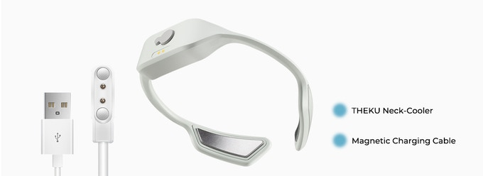

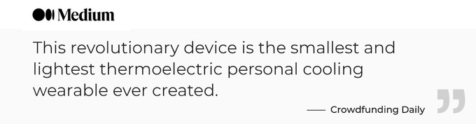

Choice of White or Grey, Medium or Large

